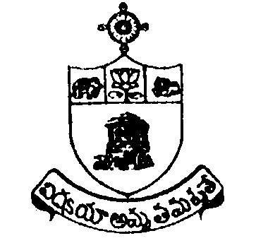SRI KRISHNADEVARAYA UNIVERSITY

NO DUES CERTIFICATE
(Teaching Staff)
Name | Designation
 | Date of Superannuation
Prior intimation of the University (Memo No. of. date)
Administrative Posts held (In case of teaching faculty) obtain No Dues from the concerned H.O.D
I) from to
II) from to
III) from to
IV) from to
Instructions
``No dues” issuing authority shall verify all the records before issuing No Dues Certificate to a retired employee
- No dues shall not be issued subject to any kind of conditions by H.O.D
- Issuing authority shall sign only when incumbent clears all the dues to the university.
- Heads of the section shall bear responsibility for issuing any defect No Dues Certificate.
- In case of teaching faculty H.O.D shall certify only after handing over all the equipments/ books etc.,
Purchased during respective projects to the department by the teacher.
1. | Department /Section  (Where Working) | :
2. | University Library | :
3. | Principal’s Office | :
4. | U.G.C. Section  (For Teaching Staff under taken project works and others etc.,) | :
5. | Finance & Accounts Section | :
6. | Others, HOD s  (Administrative posts held) | :

I hereby undertake that in the event of any` dues’ comes to light at a later date, I will settle the dues amounts if any, I authorize the university to deduct such dues amount to the University from my retirement benefits. I have not suppressed any kind of dues pending to the University.
Signature of the Employee
Date:
Place:

